Music Site Proposal

The site I want to build for the final project is one where any user can listen to songs, logged in users can see song info, and verified users can post songs. The basic idea of the site is that any user should be able to listen to files submitted either on the home page or on the page specific for showing all submitted files but nothing else. Users should be able to view song details as well as do everything that non-users can but should be unable to submit a file to the server until I give them permission to do so. Users with a submitter role will be allowed to access a form to submit a file and its metadata to the database. The files should be limited to 20mb maximum and the file types that can be submitted should be limited only to:

* .mp3
* .flac
* .ogg
* .wav

The site should have the following controllers: Home, User, Access, Info, Submission, and Playback. The top nav bar on the site will provide navigations between the home pages of each of those controllers with the sub links being present on the page in some form (hyperlink or button).

The home controller will have an index view that displays a short blurb about the site as well as one or two of the most recently posted music files with some info (user who submitted it, artist/group name, song title) that can be played back.

The user and access controllers will have views and methods relating to identity user as well as the custom user properties I decide to implement, such as user roles. The views won’t be much different than what identity and the book already provides.

The info controller will contain views for several content categories. The home page will be all submissions, it will show every user submission as well as all the data that user provided within that submission. It will be filterable by user and sortable by date submitted. The songs page will contain only info relating to the song itself such as length, artist/group, release date, and length. It will be filterable by artist and sortable by year released. The albums page will contain only info about the album, things like track amount, contributing artists, album name, and release date will be included. This view will be filterable by artist and sortable by album name alphabetically. The artists’ page will include information about the individual artists, properties like their public alias, affiliated labels, and first and last names should be included if known. It will be filterable by label affiliations and sortable by public alias alphabetically. Below is the full list of controllers and views as well as preliminary design mockups:

Home Controller

* Index – plays music

User Controller

* Index – manage users
* Add

Access Controller

* Login – access account
* Register – create account
* Access Denied – generic view if you do not have the role to access a view

Info Controller

* Submissions (index) - filter by user, sort by date
* Songs - filter by artist, sort by release year
* Albums - filter by artist, sort by album name alphabetically
* Artists - filter by label affiliations, sort by public alias alphabetically

Submission Controller

* Submit (index) – form to submit a song
* Submission State – success or failure to submit

Playback Controller

* Playback (index) – a list of song files that can be played back with small amount of metadata

Home Page:

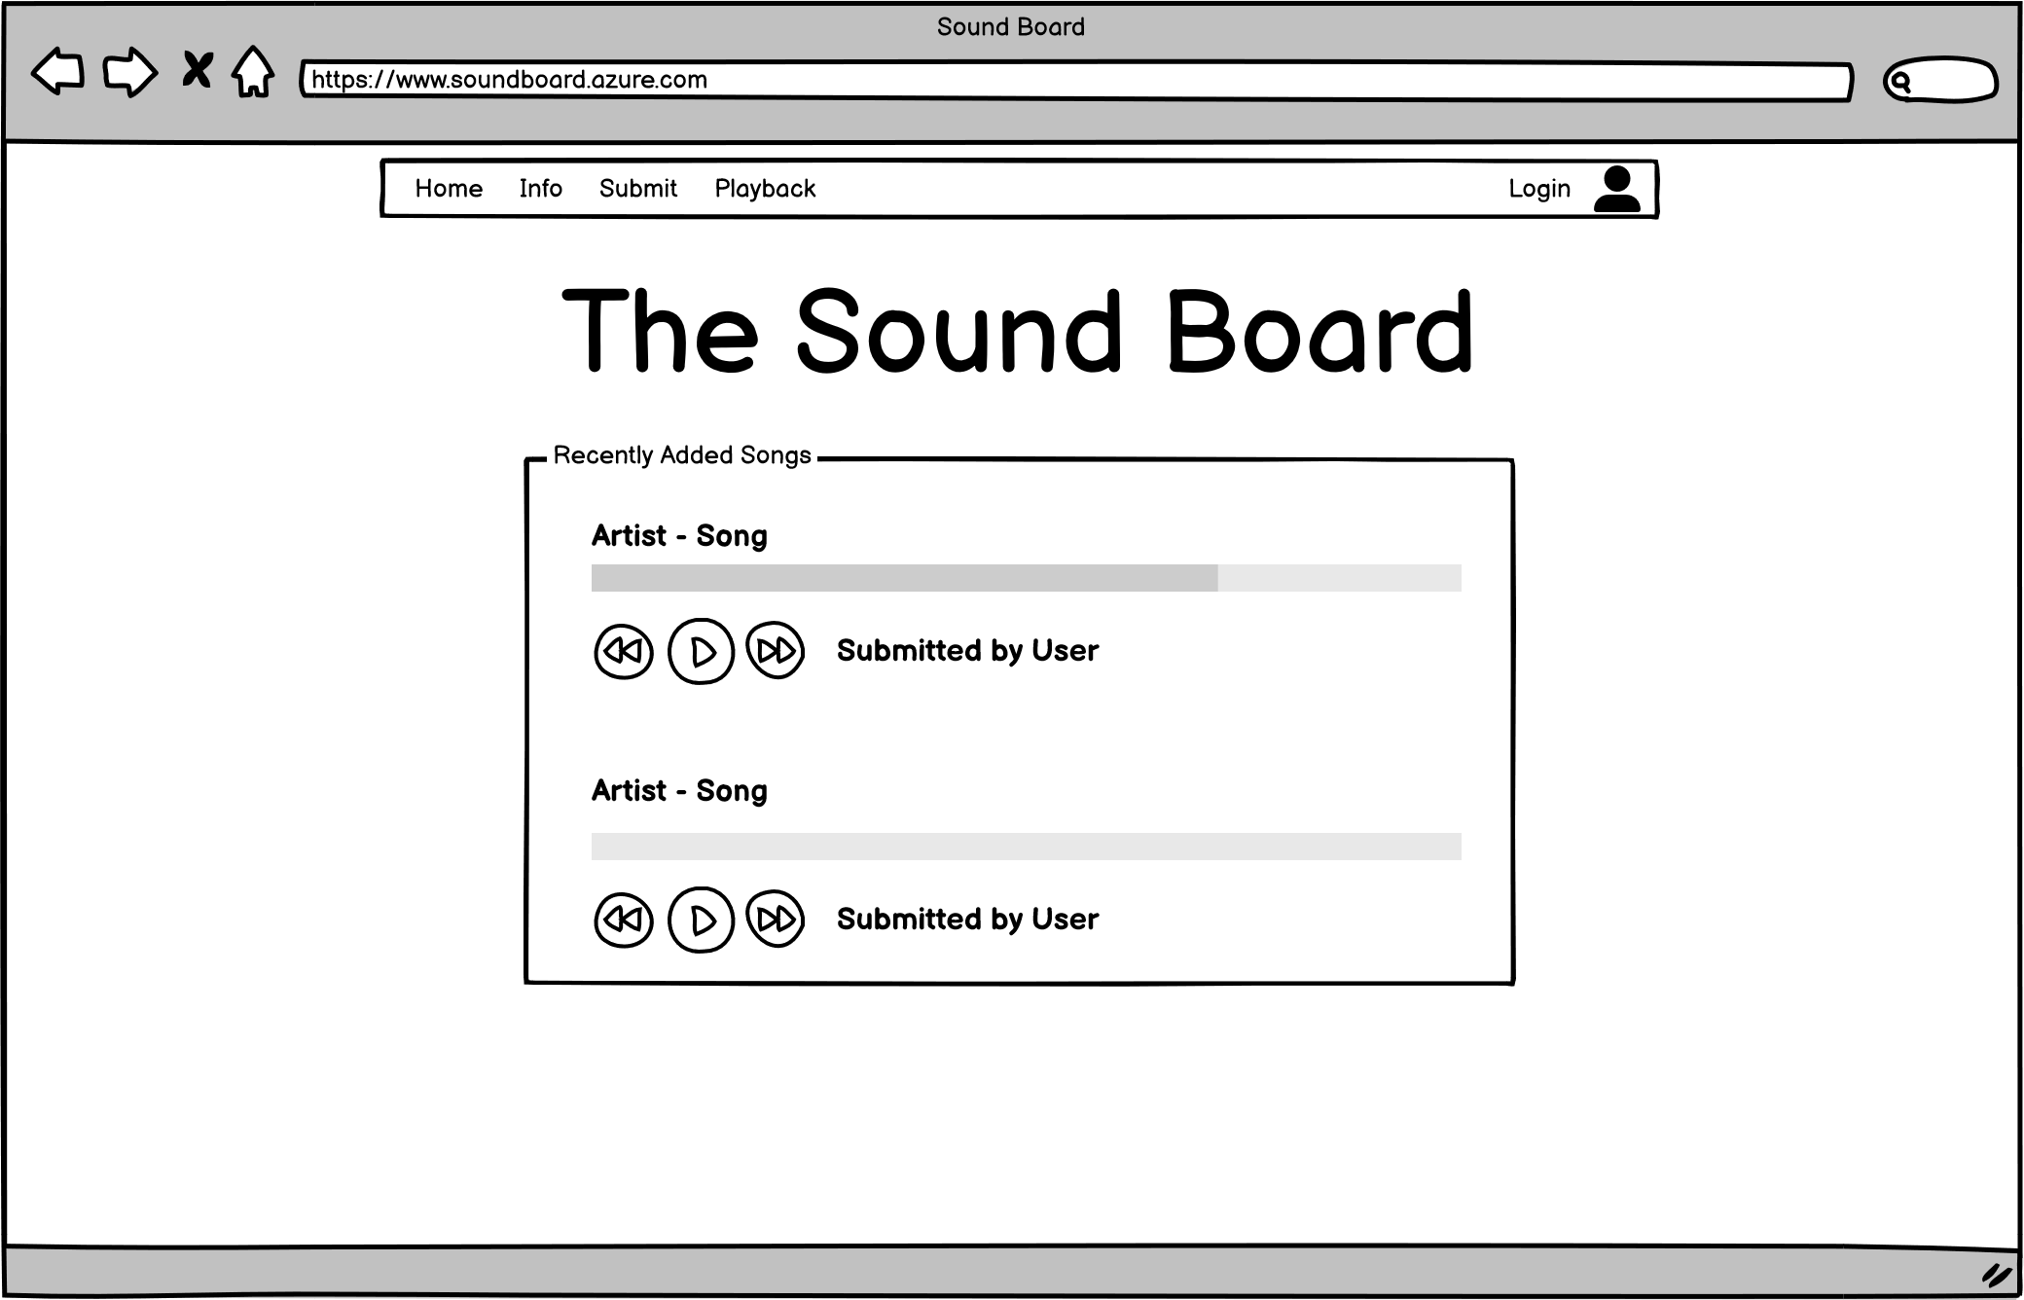

Info Page:

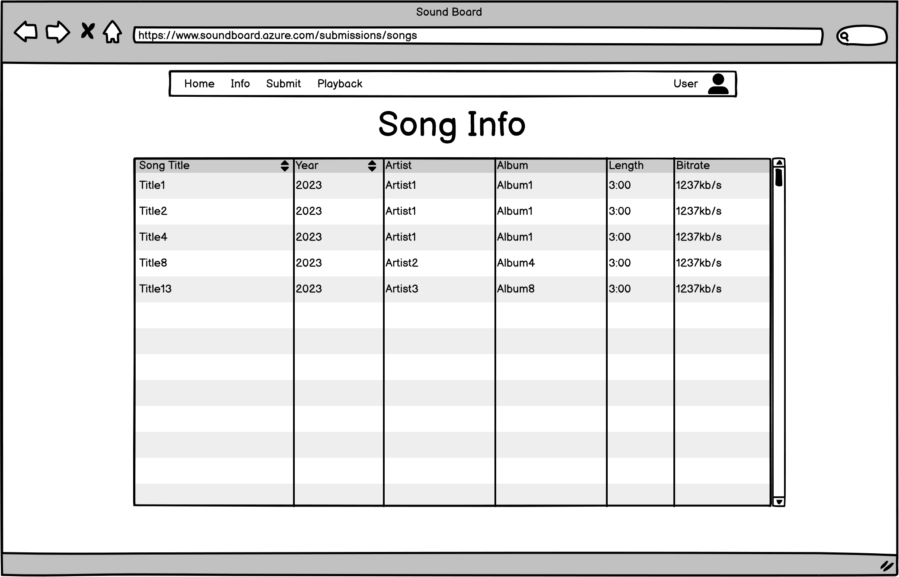

Submit Page:

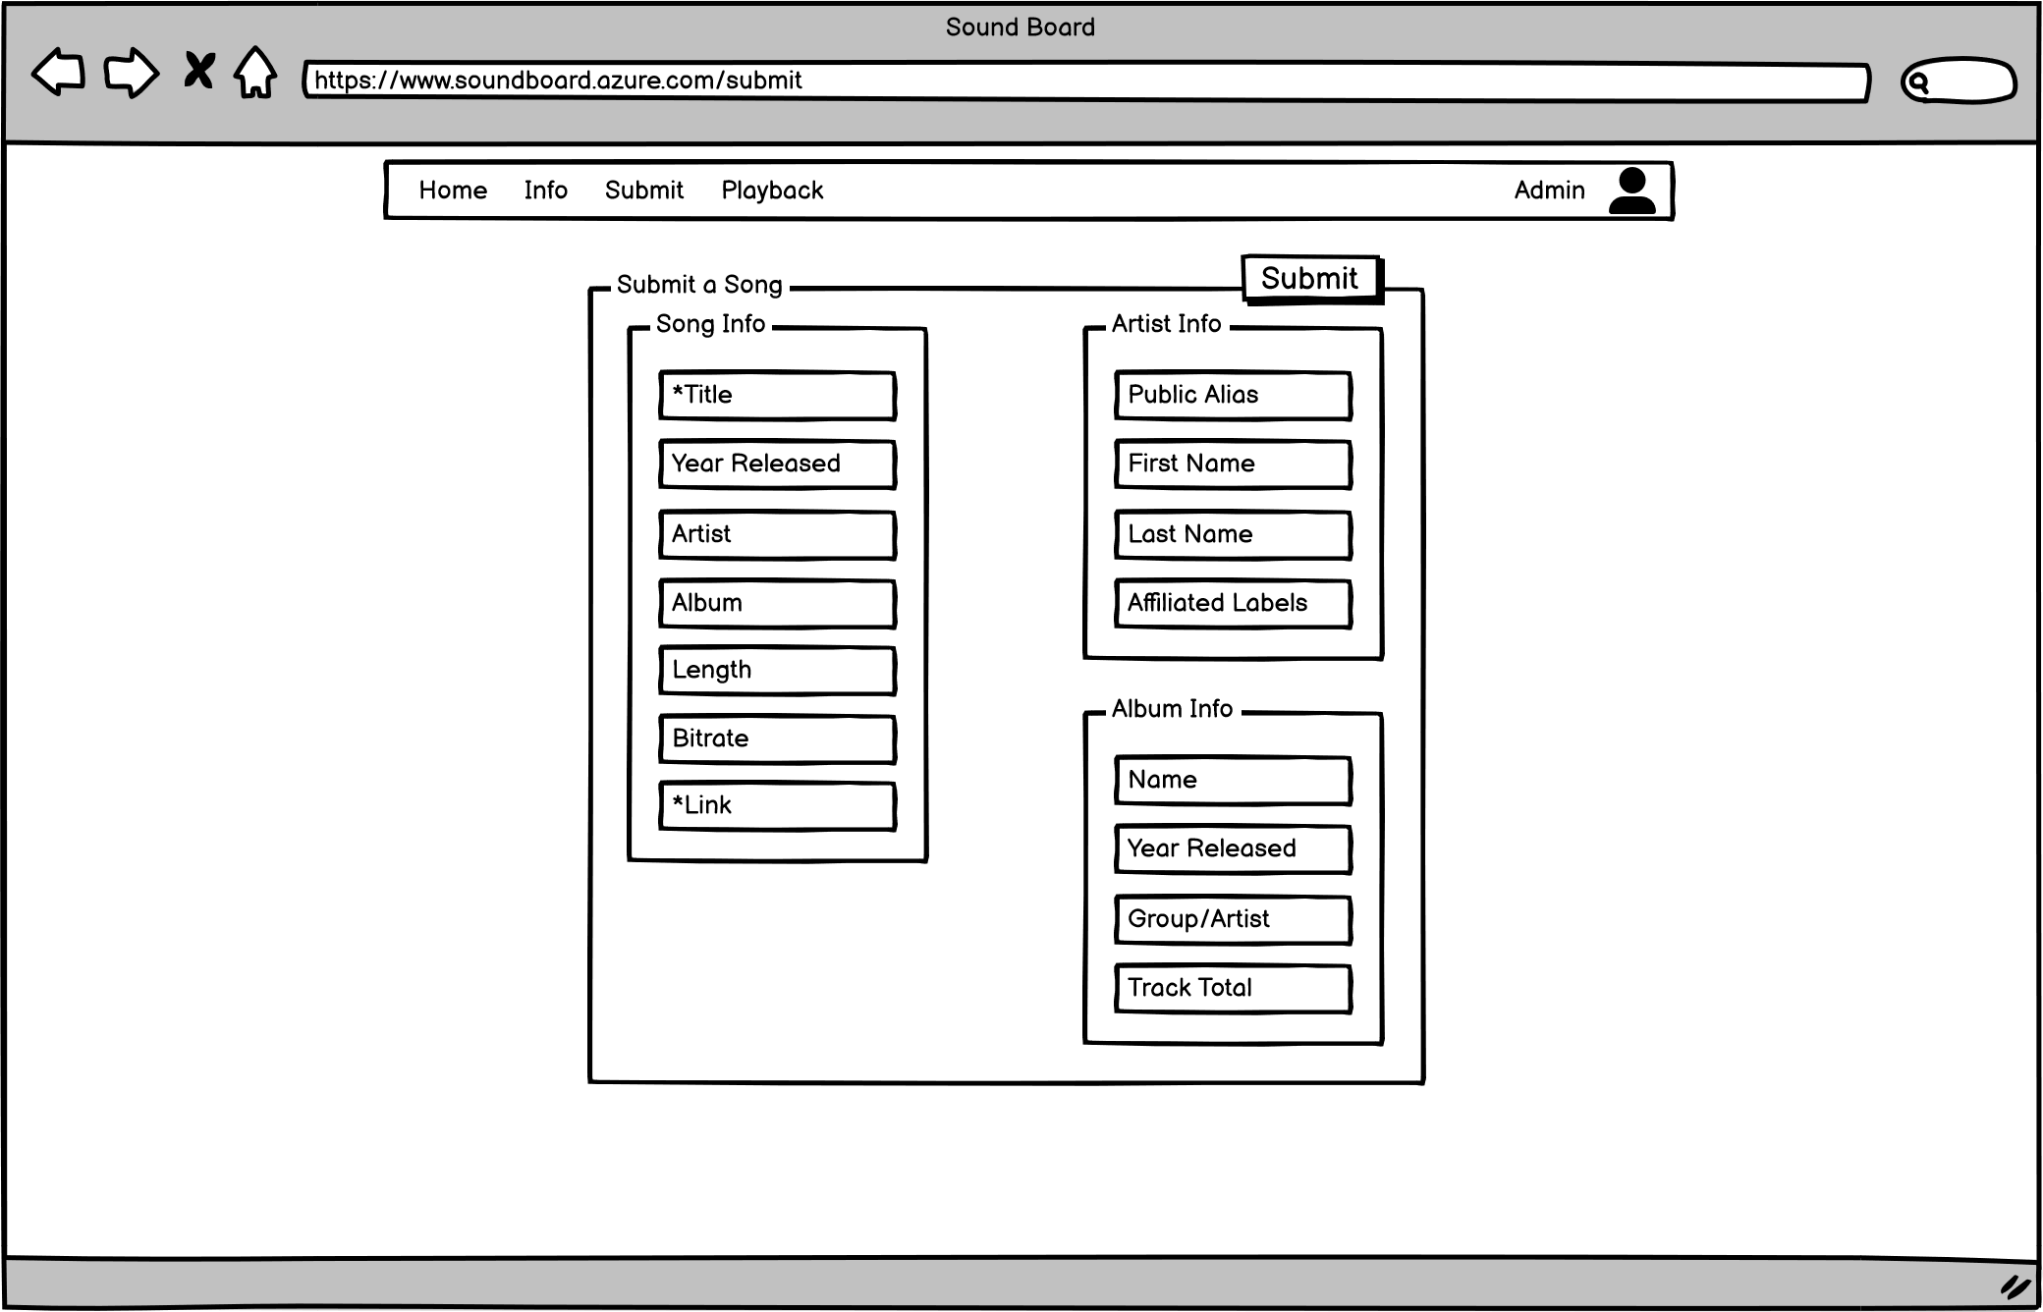

Playback Page:

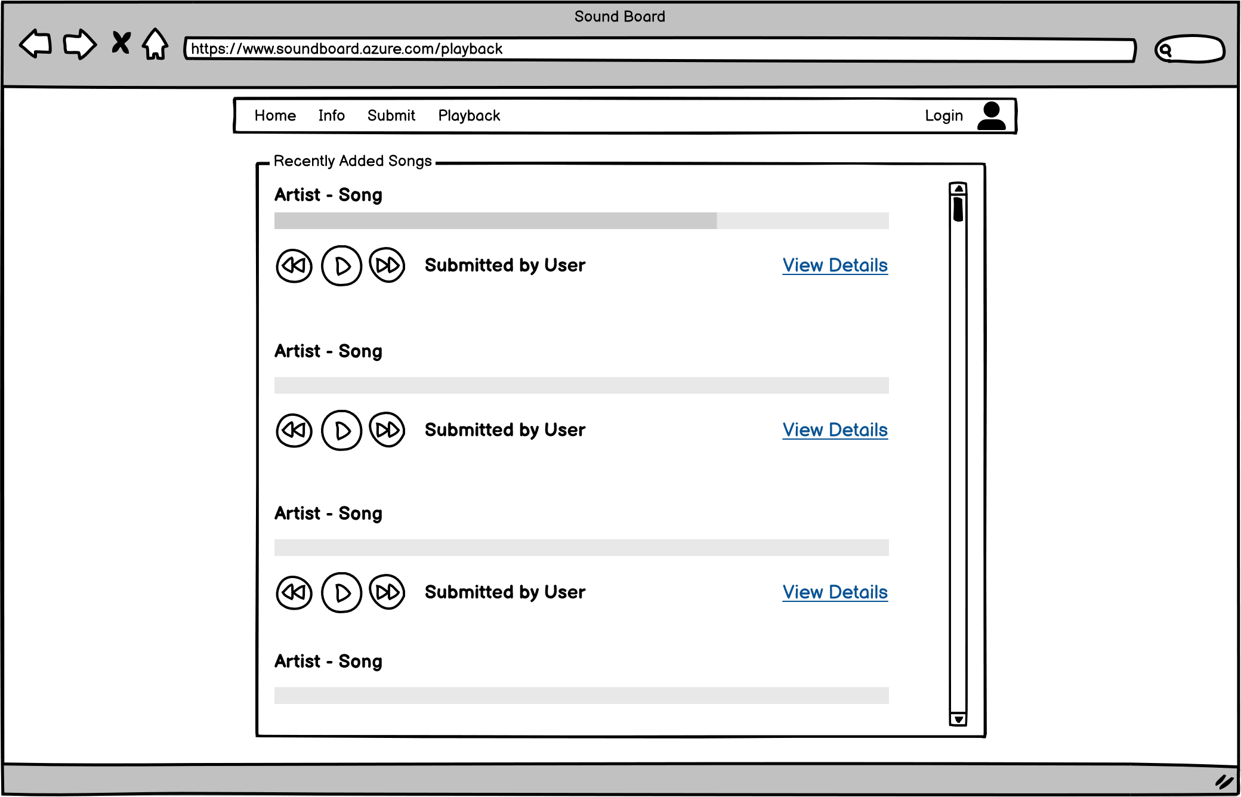

List of domains and properties:

IdentityUser

AppUser

* UserName
* Role

Submission

* SubmissionId
* Song
* DateSubmitted

Song

* SongId
* Title
* ReleaseDate
* Artist
* Album
* Length
* Bitrate
* Link

Album

* AlbumId
* Name
* Group
* ReleaseDate
* Tracktotal
* Label

Artist

* ArtistId
* PublicAlias
* FirstName
* LastName
* AffiliatedLabels

See next page for UML diagram.

UML Diagram:

